**Mini Project**

**On**

**INDIAN TOURISM WEBSITE**

Shivajirao S. Jondhale College of Engineering

Group Member list: Roll no.

1. Akshay Shinde 92
2. Snehal Shipalkar 93
3. Mukesh Tajne 97
4. Durvesh Ture 100
5. Supriya Vyavahare 102
6. Ragini Yadav 104
7. Reshma B Zaware 106
8. Priyanka Walnekar

Guided By

(Nagamani K.)

INDIAN TOURISM WEBSITE

**Project Title :** INDIAN TOURISM WEBSITE

**Introduction :**

It is an Indian Tourism Information System. Customers

Can get Information at their fingertips. It also provides various

Advantages of our tourist system to customers to Our System.

We provide valuable services in favor of our customers.

**Objective :**

* Easy to fetch information of places from website.
* Virtually explores places in India.
* We provide Images almost of all the Places.
* We provide information about all Tourists points,

Accommodation , Shopping Attractions etc.

**Purpose :**

* It serves as a means to know various places.
* Tourism in historical places lets one know about the rich history, people of that time and place, the architecture etc. By visiting Beaches, Landscapes, Hillstations, people get away from their usual day to day work and get relaxed, rejuvenated, and motivated.
* We get awed, and marvelled at the various aspects, beauties and colours of nature.
* Tourism as pilgrimage serves the purpose of getting peace, and for spiritual needs. Visiting National Parks, Wildlife Sanctuaries, and forests, one gets closer to nature and also mesmerized by the animals, trees, birds and many more...

**Features *:***

* The new policy centers around seven broad objectives known as Seven S’s. Welcome (Swagat), Information (Suchana), Facilitation (Suvidha), Security (Suraksha). Cooperation (Sahyog), Infrastructure Development (Sanrachana), and cleaniness (Safaai) which are the main areas of operation in the policy
* The Indian Tourism designs national policies for the development and promotion of tourism

**Software Requirements:**

Operating System : Window os

Web Technology :

Client side:- Html,CSS,JavaScript

Server side:- php

**Hardware Requirements:**

Ram :-4 GB

1. **HTML**

[HTML](https://googleweblight.com/?lite_url=https://developer.mozilla.org/en-US/docs/Glossary/HTML&lc=en-IN&s=1&m=156&host=www.google.co.in&ts=1477412382&sig=AF9Nedn170ShRJZCefOgdI524BGlRZECdg) is a**markup language**. The word markup was used by editors who marked up manuscripts (usually with a blue pencil) when giving instructions for revisions. "Markup" now means something slightly different: a language with specific syntax that instructs a Web browser how to display a page. Once again, HTML separates "content" (words, images, audio, video, and so on) from "presentation" (instructions for displaying each type of content). [HTML](https://googleweblight.com/?lite_url=https://developer.mozilla.org/en-US/docs/Glossary/HTML&lc=en-IN&s=1&m=156&host=www.google.co.in&ts=1477412382&sig=AF9Nedn170ShRJZCefOgdI524BGlRZECdg) uses a pre-defined set of[elements](https://googleweblight.com/?lite_url=https://developer.mozilla.org/en-US/docs/Glossary/Element&lc=en-IN&s=1&m=156&host=www.google.co.in&ts=1477412382&sig=AF9Nedm76AIjPt7kZQo8Lom_St55SAl5kA) to define content types. Elements contain one or more "[tags](https://googleweblight.com/?lite_url=https://developer.mozilla.org/en-US/docs/Glossary/Tag&lc=en-IN&s=1&m=156&host=www.google.co.in&ts=1477412382&sig=AF9NedkZogUPt2ece-cs7pvnkcHaw50FBw)" that contain or express content. Tags are enclosed by angle brackets, and the closing tag begins with a forward slash.

[HTML](https://googleweblight.com/?lite_url=https://developer.mozilla.org/en-US/docs/Glossary/HTML&lc=en-IN&s=1&m=156&host=www.google.co.in&ts=1477412382&sig=AF9Nedn170ShRJZCefOgdI524BGlRZECdg) consists of a set of [**elements**](https://googleweblight.com/?lite_url=https://developer.mozilla.org/en-US/docs/Glossary/Element&lc=en-IN&s=1&m=156&host=www.google.co.in&ts=1477412382&sig=AF9Nedm76AIjPt7kZQo8Lom_St55SAl5kA), which define the **semantic** meaning of their content. Elements include two matching [tags](https://googleweblight.com/?lite_url=https://developer.mozilla.org/en-US/docs/Glossary/tag&lc=en-IN&s=1&m=156&host=www.google.co.in&ts=1477412382&sig=AF9Nedl4qqr1jqpQN7GzgUrdOUB6Ua9ItQ) and everything in between. For example, the "<p>" element indicates a paragraph; the "<img>" element indicates an image. See the [HTML Elements](https://googleweblight.com/?lite_url=https://developer.mozilla.org/en-US/docs/HTML/Element&lc=en-IN&s=1&m=156&host=www.google.co.in&ts=1477412382&sig=AF9NednuJ7mN1bHDaXCxDiMGBkYo9ajtpw) page for a complete list. Note: Some tags are self-closing and do not contain any content.

Some [elements](https://googleweblight.com/?lite_url=https://developer.mozilla.org/en-US/docs/Glossary/Element&lc=en-IN&s=1&m=156&host=www.google.co.in&ts=1477412382&sig=AF9Nedm76AIjPt7kZQo8Lom_St55SAl5kA) have very precise meaning, as in "this is an image", "this is a heading", or "this is an ordered list". Others are less specific, such as "this is a section on the page" or "this is part of the text". Yet others are used for technical reasons, such as "this is identifying information for the page, so do not display it". Regardless, in one way or another all HTML elements have a semantic value.

Most elements may contain other elements, forming a hierarchical structure.

1. **CSS**

A CSS (cascading style sheet) file allows you to separate your web sites (X)HTML content from it’s style. As always you use your (X)HTML file to arrange the content, but all of the presentation (fonts, colors, background, borders, text formatting, link effects & so on…) are accomplished within a CSS.

At this point you have some choices of how to use the CSS, either internally or externally.

**C**ascading **S**tyle **S**heets, fondly referred to as CSS, is a simple design language intended to simplify the process of making web pages presentable.

CSS handles the look and feel part of a web page. Using CSS, you can control the color of the text, the style of fonts, the spacing between paragraphs, how columns are sized and laid out, what background images or colors are used, layout designs,variations in display for different devices and screen sizes as well as a variety of other effects.

CSS is easy to learn and understand but it provides powerful control over the presentation of an HTML document. Most commonly, CSS is combined with the markup languages HTML or XHTML.

**3)JAVASCRIPT**

JavaScript is most commonly used as a client side scripting language. This means that JavaScript code is written into an HTML page. When a user requests an HTML page with JavaScript in it, the script is sent to the browser and it's up to the browser to do something with it.

The fact that the script is in the HTML page means that your scripts can be seen and copied by whoever views your page. Nonetheless, to my mind this openness is a great advantage, because the flip side is that you can view, study and use any JavaScript you encounter on the WWW.

JavaScript can be used in other contexts than a Web browser. Netscape created server-side JavaScript as a CGI-language that can do roughly the same as Perl or ASP. There is no reason why JavaScript couldn’t be used to write real, complex programs. However, this site exclusively deals with the use of JavaScript in web browsers.

If you don’t have any programming experience at all it’s best to start with some gentle JavaScript examples that teach you the basics. It might be a good idea to buy Negrino & Smith, “[JavaScript for the World Wide Web](http://googleweblight.com/?lite_url=http://www.javascriptworld.com/&lc=en-IN&s=1&m=12&host=www.google.co.in&ts=1477415679&sig=AF9NednNJT5Ngk4IdwcbE6R39h2Jq3TKAQ)”, 4th edition, Peachpit Press, 2001. It contains some very useful examples and though it doesn’t treat advanced programming tricks, it will certainly help you get started. Of course this site also offers plenty of help.

I can also recommend Jeremy Keith, [DOM Scripting: Web Design with JavaScript and the Document Object Model](http://googleweblight.com/?lite_url=http://domscripting.com/book/&lc=en-IN&s=1&m=12&host=www.google.co.in&ts=1477415679&sig=AF9NednzHp9CkaNs4XOHuYEyxpFSoGNdiA), 1st edition, Friends of Ed, 2005. This, too, is a book that doesn't delve too deeply into technology, but gives non-programmers such as graphic designers/CSS wizards an excellent overview of the most common uses of JavaScript - as well as the most common problems.

**Homepage.html**

<html>

<head>

<title>Homepage</title>

<link rel="stylesheet" href="styles.css">

</head>

<frameset rows="24%,76%">

<frame src="toppage.html" name="top_page" />

<frameset cols="14%,86%">

<frame src="leftpage.html" name="left_page" />

<frame src="rightpage.html" name="right_page" />

<noframes>

<body>

Your browser does not support frames.

</body>

</noframes>

</frameset>

</frameset>

</html>

**Rightpage.html**

**<**!DOCTYPE HTML PUBLIC "-//W3C//DTD HTML 4.01 Transitional//EN">

<html><head>

<link rel="stylesheet" href="styles.css">

<title>home.html</title></head>

<body>

<center><big>

</big><h1 style="color: blue;"><big>HOME</big></h1><big>

</big></center>

<br>

<h1 style="color: blue;">&nbsp; &nbsp; &nbsp; &nbsp; &nbsp; &nbsp; <img style="width: 926px; height: 366px;" alt="5" src="5.jpg"></h1><span style="font-weight: bold;"><br></span>

<big>

</big>

<div style="text-align: justify;">

<div style="text-align: justify;"><big>&nbsp;

&nbsp; &nbsp; &nbsp; &nbsp; &nbsp;

&nbsp;&nbsp; &nbsp; <big>&nbsp;</big></big><big><big>Welcome to our

website<strong> "HappyJourney.com"</strong>. Here you can get information about

Historical&nbsp;places, Religious places and so on from all over

the India. Here we are providing information about History &nbsp;of

particular place, it's Architecture, Nearby Tourist Attractions, nearby

Hotels and photos of all the places.</big></big>

<p id="demo" style="display:none">

<big><big>Whether

you're a new-age traveller seeking quirky experiences, planning a

family vacations to aa popular destination, or an armchair wanderer

soaking in images of far-off lands, you'll find it all here.We'll tell

you where to go,what to do when you're there, where to stay.</big></big><big><big><br>There

are still frontiers out there. And we'll take you right to the edge by

bringing you real-life explorations by travellers around the world.</big></big><br><big><big>HappyJourney

also gives you information about nearby places to visit for sightseeing. List of nearby hotels to stay.</big></big>

<big><big>&nbsp; &nbsp; &nbsp; &nbsp;

&nbsp; By visiting this website you can virtually explore all these

places. </big></big><br>

<big><big>&nbsp; &nbsp; &nbsp; &nbsp;

&nbsp; You can choose a perfect place to visit by just one click on

HappyJourney.com .</big></big></p></div>

<href onclick="document.getElementById('demo').style.display='block'"><big><big><b>Read more</b></big></big>

</button><p></p></div>

<big><big><br>

</big></big>

<br>

&nbsp; &nbsp;

HappyJourney.com . </body></html>

**Leftpage.html**

<!DOCTYPE HTML PUBLIC "-//W3C//DTD HTML 4.01 Transitional//EN">

<html><head><title>leftpage</title>

</head>

<body style="color: white; background-color: rgb(255, 204, 0);" alink="#ee0000" link="#0000ee" vlink="#551a8b">

<h3 style="background-color: rgb(255, 204, 0);">

<a href="home.html" target="right_page">Home</a>

<br>

<br>

<a href="history.html" target="right_page">Historiacal

Places</a>

<br>

<br>

<a href="religious.html" target="right_page">Religious

Places</a>

<br>

<br>

<a href="hillstations.html" target="right_page">Hill

Stations</a>

<br>

<br>

<a href="aboutus.html" target="right_page">About Us</a>

</h3>

</body></html>

**Top page.html**

<!DOCTYPE HTML PUBLIC "-//W3C//DTD HTML 4.01 Transitional//EN">

<html><head><title>toppage</title></head>

<body style="background-image: url(tajcrop.jpg);">

<big><big><big><big><big><big>&nbsp; &nbsp; <big><span style="color: white;">HappyJourney.com</span></big></big></big></big></big></big></big><br>

</body></html>

**Historical.html**

<!DOCTYPE HTML PUBLIC "-//W3C//DTD HTML 4.01 Transitional//EN">

<html><head>

<title>History</title><link rel="stylesheet" href="styles.css"></head>

<body>

<center><h1><b>HISTORICAL PLACES</b></h1></center>

<br>&nbsp; &nbsp; &nbsp; &nbsp; &nbsp; &nbsp; &nbsp; &nbsp;&nbsp; &nbsp; &nbsp;<img style="width: 944px; height: 467px;" alt="histry" src="India-Gadi-Sagar-Temple.jpg"><br>

<p><big></big></p><p><big>&nbsp; &nbsp; &nbsp; &nbsp; &nbsp; &nbsp;

&nbsp; &nbsp;When it comes to historical places in India, the country

is peppered with whimsical domes, soaring minars, pristine structures

that are reminiscent of the British era,and religious centres that have

an iconic heritage value. </big></p>

<p><big>&nbsp; &nbsp; &nbsp; &nbsp; &nbsp;From the eternal love symbol in Agra called

Taj Mahal, which is one of the wonders of the world, to Mumbai's icon Gateway of India,

these places to visit in India are most popular amongst domestic and international

travellers.

</big></p>

<p><big>&nbsp; &nbsp; &nbsp; &nbsp;So if you're planning a trip to India then head to these centuries-old structures

and monuments that will leave you totally awestruck with their regal splendour,

old-world charm and historical significance.</big>

</p>

<br>

<a href="tajmahal.html" target="right_page"><center>TAJ MAHAL</center></a><br><br>

<a href="gateway.html" target="right_page"><center>THE GATEWAY OF INDIA</center></a><br><br>

<a href="qutub.html" target="right_page"><center>QUTAB MINAR</center></a><br><br>

<a href="hawamahal.html" target="right_page"><center>HAWA MAHAL</center></a>

</body></html>

**Tajmahal.html**

<!DOCTYPE HTML PUBLIC "-//W3C//DTD HTML 4.01 Transitional//EN">

<html><head><title>tajmahal</title>

<link rel="stylesheet" href="styles.css">

</head>

<body>

<c></c>

<h1><b>TAJ MAHAL<a name="top"></a></b></h1>

<br>

<br>

<img style="width: 594px; height: 397px;" src="Taj%20Mahal.jpg" alt="taj mahal">

<h2>History</h2>

<br>

<big>The Taj Mahal is described as a &#8220;teardrop on the face of

eternity&#8221; by legendary poet Rabindranath Tagore. The Taj Mahal is

considered by many, to possess architectural beauty unsurpassed by any

other structure in the world.</big>

<p id="demo" style="display:none"><big>

Constructed over a period of 22 years, employing twenty thousand

workers, it was completed in 1648 C.E. and costed a whopping 32 million

Rupees. Built entirely of white marble, it almost seems to glow in the

moonlight, with the shimmering Jamuna river situated just across. The

Muslim emperor Shah Jahan built this monument in the memory of his wife

Mumtaz, whose grave is housed within the premises at the lower chamber.

The grave of Shah Jahan was added to it later.</big></p>

<href onclick="document.getElementById('demo').style.display='block'"><big><big><b>Read more</b></big></big>

</button><br>

<br>

<img style="width: 594px; height: 397px;" src="Taj-mahal-night.jpg" alt="taj mahal">

<br>

<big>The Taj stands tall and regal on a raised, square platform,

forming an unequal octagon with its four truncated corners. The

architecture uses the interlocking arabesque concept, where each

element is singular in its entirety, but integrates seamlessly with the

whole. The central dome spans 58 feet in diameter and soars to a height

of 213 feet. It is flanked on four sides by smaller domed chambers,</big>

<p id="demo" style="display:none"><big> and

four slender minarets rising to a lower height of 162.5 feet. The

entire mausoleum is decorated with an inlaid design of flowers and

calligraphy using precious gems like agate and jasper, and the main

archways are carved with passages from the Holy Qur&#8217;an.</big>

</p>

<href onclick="document.getElementById('demo').style.display='block'"><big><big><b>Read more</b></big></big>

</button><br>

<br>

<img style="width: 594px; height: 397px;" src="inside%20taj.jpg" alt="taj mahal">

<br>

</href>

<h2> Astonishing facts about the Taj Mahal</h2>

<p><big>

Symbol of true love and one of the Seven Wonders of the World, the Taj

Mahal is amongst country's most visited tourist attractions. Displaying

a beautiful mix of Islamic, Persian and Indian architecture, this

historic marvel was built in over 22 years, with the help of about

20000 workers. Despite its popularity, there are several facts people

still do not know about the Taj Mahal. Listed below are some of the

points that'd surely enhance your knowledge about this marble mausoleum:</big></p>

<p><big>1. You won't believe but the replicas of the Taj

Mahal do exist. </big></p>

<p id="demo" style="display:none">

<big>Though not as breathtaking as the original Taj, Bibi Ka

Maqbara in Aurangabad and Taj Mahal Bangladesh are quite a work of art!</big><br>

<big>2. Taj Mahal is adorned with an assortment of 28 types of

precious and semi-precious stones.</big><br>

<big>3. Depending upon what time of the day it is and whether or

not it is a moonlit night, Taj Mahal appears to be of different colours.</big><br>

<big>4. While roaming in Taj Mahal complex, you can see different

verses of Quran written everywhere. Mumtaz Mahal's actual tomb contains

about 99 different names of Allah featured as calligraphic inscriptions.</big></p>

<href onclick="document.getElementById('demo').style.display='block'"><big><big><b>Read more</b></big></big>

</button><br>

<h2>Nearby Tourist Attractions</h2>

<p><big>Taj Mahal marks the identity of the city of Agra;

however there are

many splendid places that exist in Agra that remains unveiled. Most of

the grandeurs are found around Taj Mahal and narrate the galore of the

Mughal era.

Agra is a reflection of majestic Mughal era and their astounding

history is a vital part of the Golden Triangle in India. Visitors

throng Agra to witness the unmatched aura of Taj Mahal. Often the

beauty of Taj Mahal overshadows other structures including Agra fort,

Fatehpur Sikri and Sikandra existing under the shelter. Without

offending the magnanimous entity of Taj Mahal, a travel enthusiast has

the right to explore cores of the wonder called Agra city.

Here is a list of places to visit in Agra near Taj Mahal that you must

follow as an authentic traveler:</big></p>

<h3>Agra Fort</h3>

<img style="width: 594px; height: 397px;" src="agrafort.jpg" alt="taj mahal">

<h3>Sikandra</h3>

<img style="width: 594px; height: 397px;" src="sikandra.jpg" alt="taj mahal">

<h3>Fatehpur</h3>

<img style="width: 594px; height: 397px;" src="fatehpur.jpg" alt="taj mahal">

<br>

<h2>Nearby Hotels in Agra</h2>

<p>1 HOTEL TAJ RESORTS

HOTELS, AGRA

ADDRESS:Plot No. 538, Near Shilp Gram, Estern Gate, Agra 282001

</p>

<img style="width: 594px; height: 397px;" src="hotel%20taj%20resort%202.jpg" alt="taj mahal">

<br>

<p>2 TAJ HAVELI

HOTELS, AGRA

ADDRESS:6, Amarlok, Taj Link Road, Near Shilp gram Parking, Agra, 282001</p>

<img style="width: 594px; height: 397px;" src="hotel%20taj%20haveli.jpg" alt="taj mahal">

<br>

<p>3 THE OBEROI AMARVILAS

HOTELS, AGRA

ADDRESS:Paktola, Tajganj, Basai, Taj East Gate Road, delhi</p>

<img style="width: 594px; height: 397px;" src="hotel%20oberoy%20taj.jpg" alt="taj mahal">

<br>

<p>4 HOTEL AMAR

HOTELS, AGRA

ADDRESS:Tourist Complex Area, Fatehabad Road, Agra 282001</p>

<img style="width: 594px; height: 397px;" src="hotel%20amar%20taj.jpg" alt="taj mahal">

<br>

<br>

<br>

<a href="tajmahal.html#top">Go TO Top</a>

<br>

<a href="history.html" target="right_page">Go To

Previous Page</a>

</body></html>

**CSS codes**

body {

background-color: powderblue;

}

**Javascript code**

<link rel="stylesheet" href="styles.css">

</head>

<body>

<c></c>

<h1><b>TAJ MAHAL<a name="top"></a></b></h1>

<br>

<br>

<img style="width: 594px; height: 397px;" src="Taj%20Mahal.jpg" alt="taj mahal">

<h2>History</h2>

<br>

<big>The Taj Mahal is described as a &#8220;teardrop on the face of

eternity&#8221; by legendary poet Rabindranath Tagore. The Taj Mahal is

considered by many, to possess architectural beauty unsurpassed by any

other structure in the world.</big>

<p id="demo" style="display:none"><big>

Constructed over a period of 22 years, employing twenty thousand

workers, it was completed in 1648 C.E. and costed a whopping 32 million

Rupees. Built entirely of white marble, it almost seems to glow in the

moonlight, with the shimmering Jamuna river situated just across. The

Muslim emperor Shah Jahan built this monument in the memory of his wife

Mumtaz, whose grave is housed within the premises at the lower chamber.

The grave of Shah Jahan was added to it later.</big></p>

<href onclick="document.getElementById('demo').style.display='block'"><big><big><b>Read more</b></big></big>

</button><br>

<br>

**Snapshots of Website**

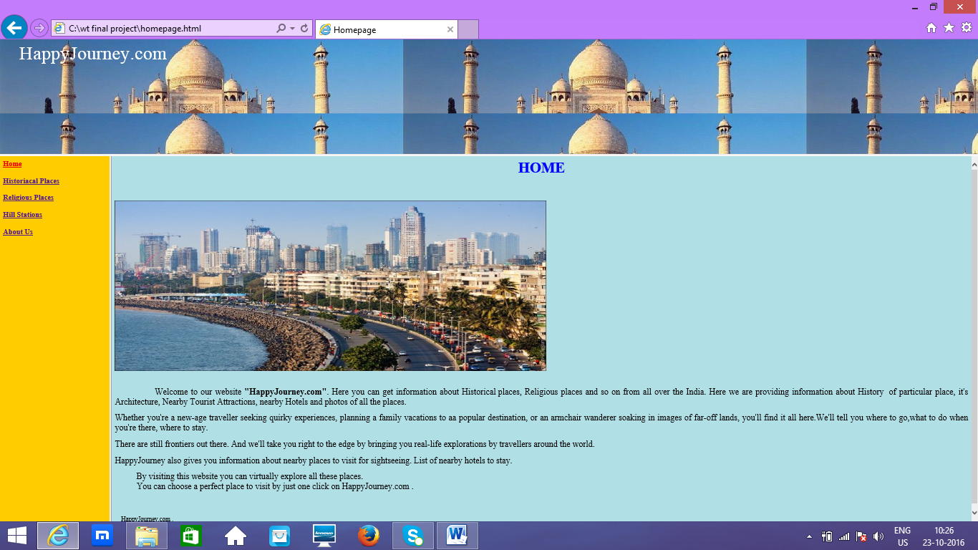

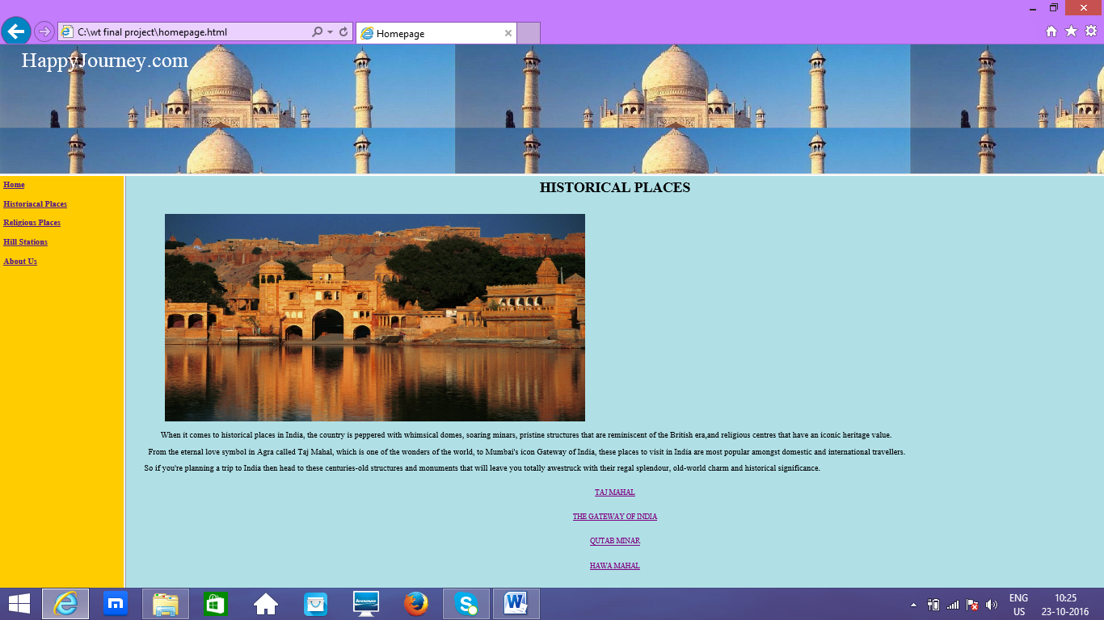

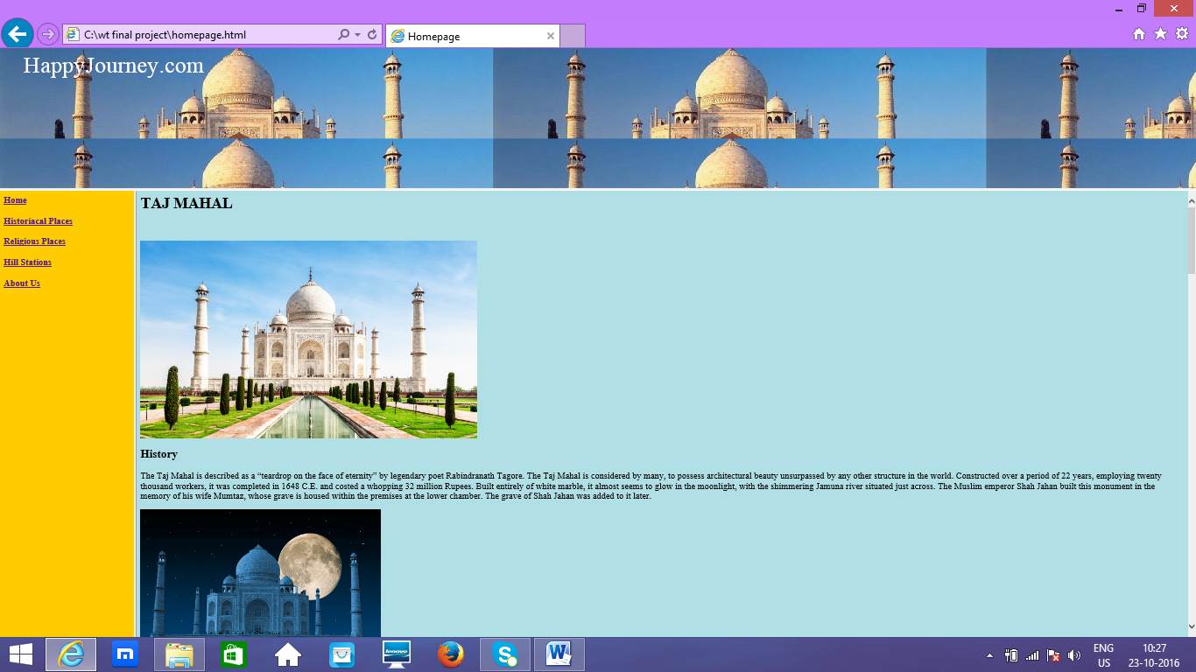

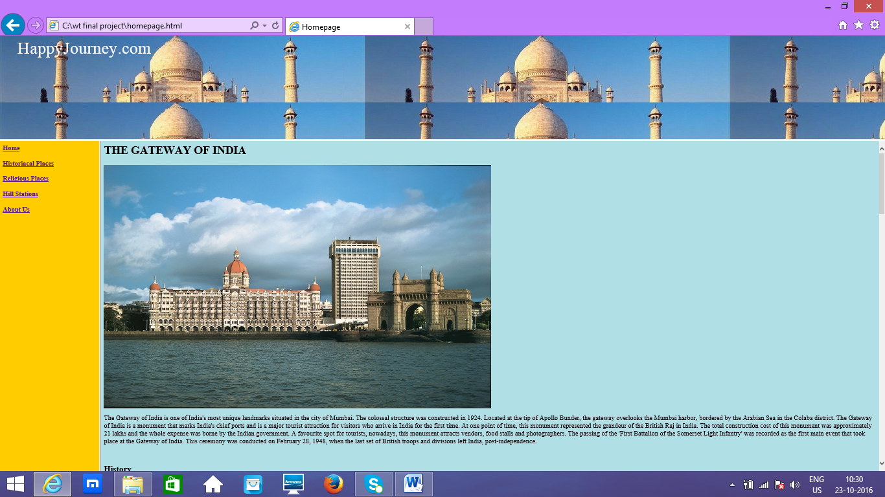

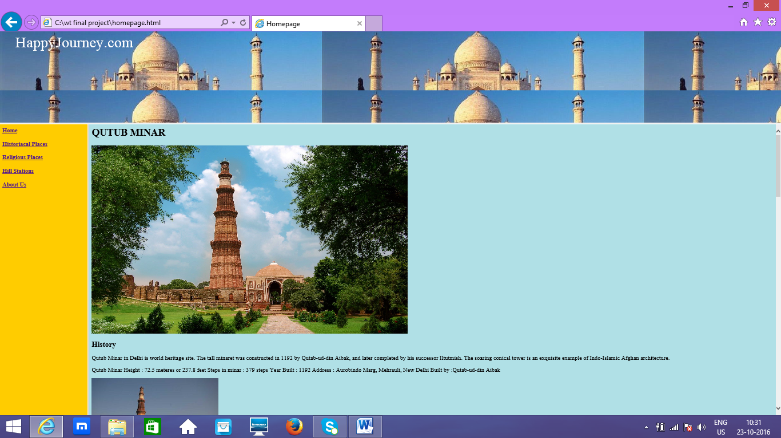

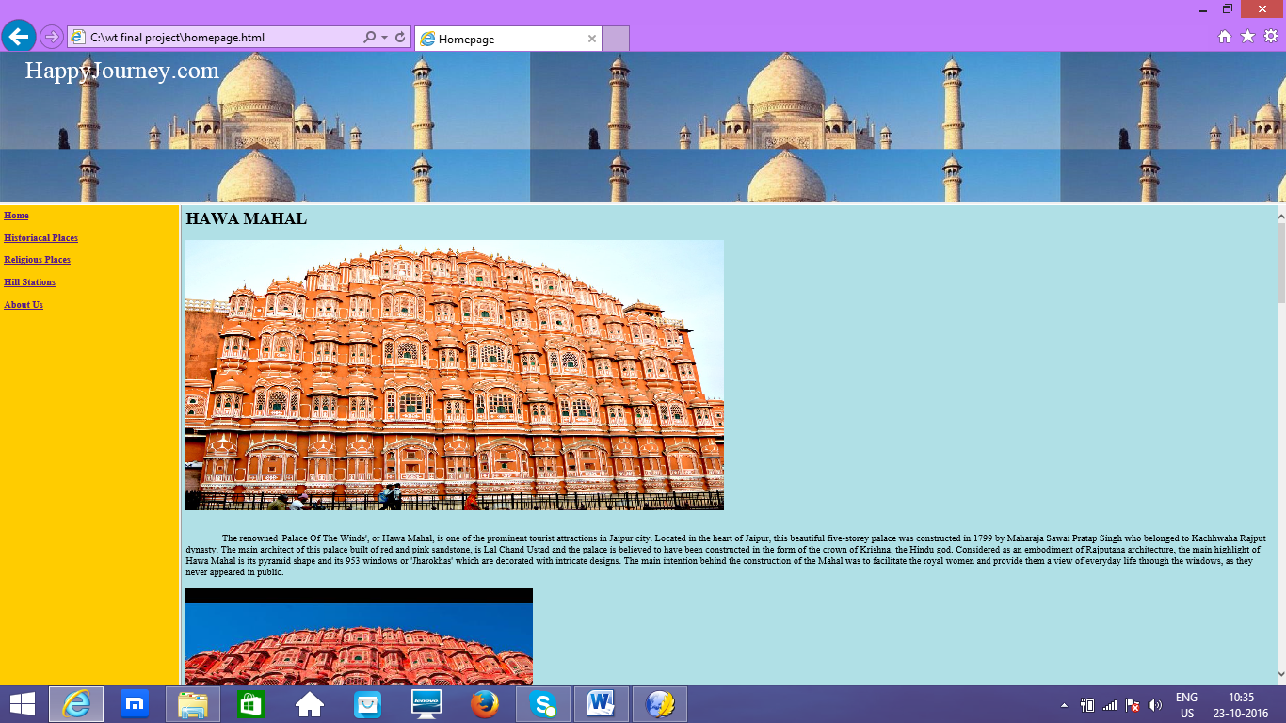

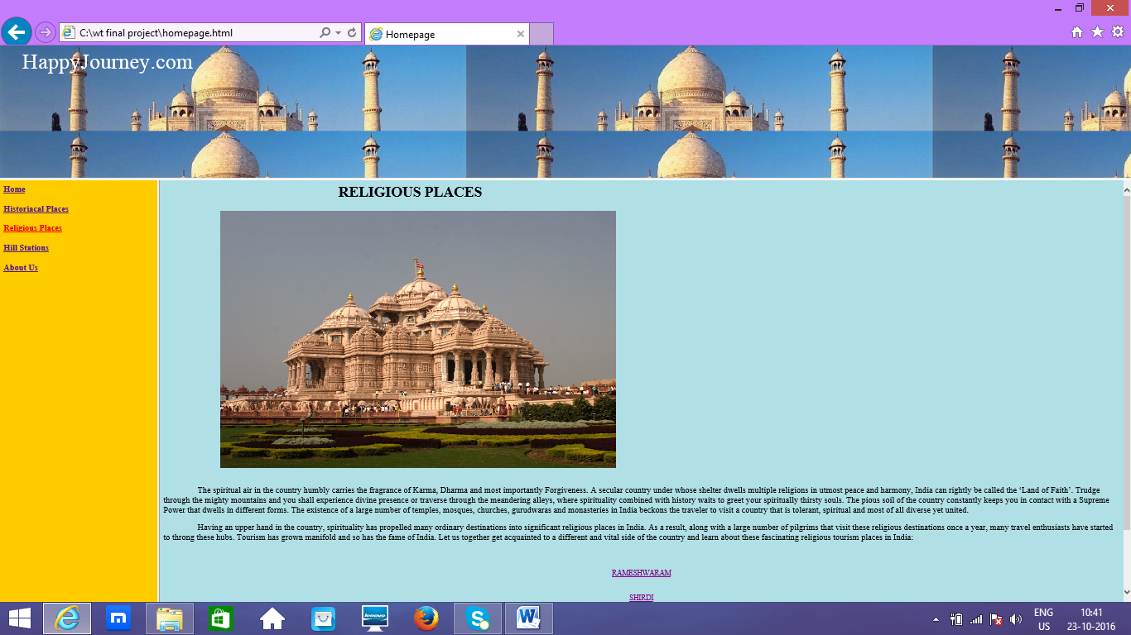

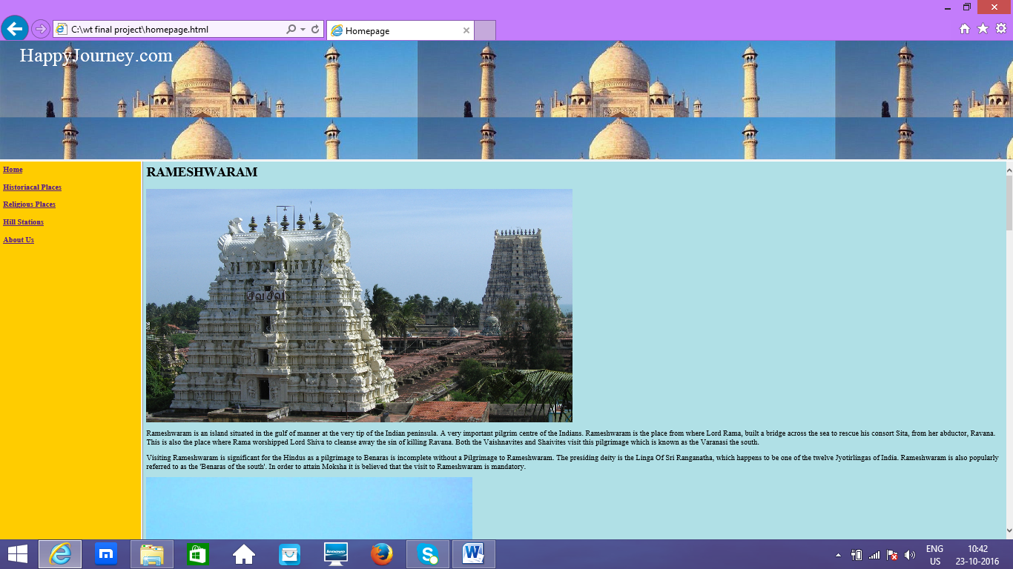

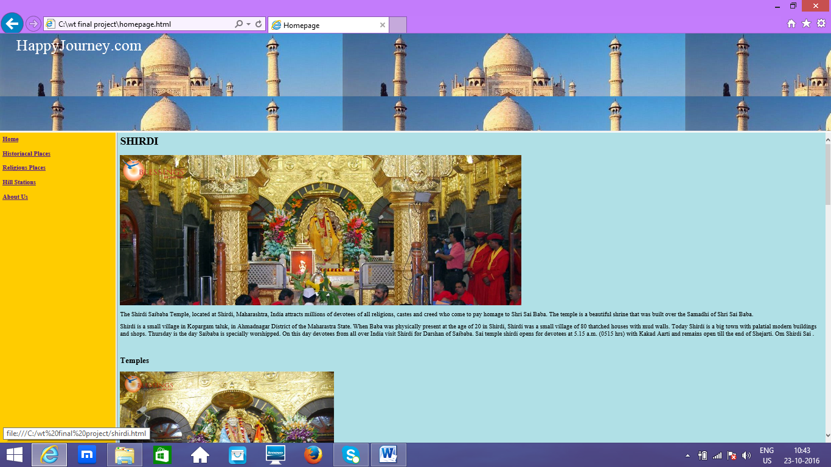

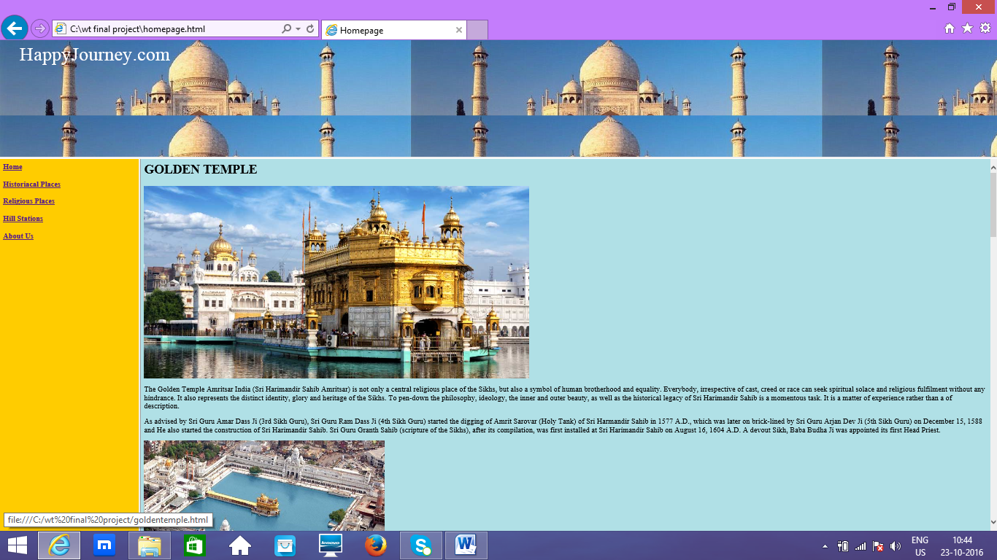

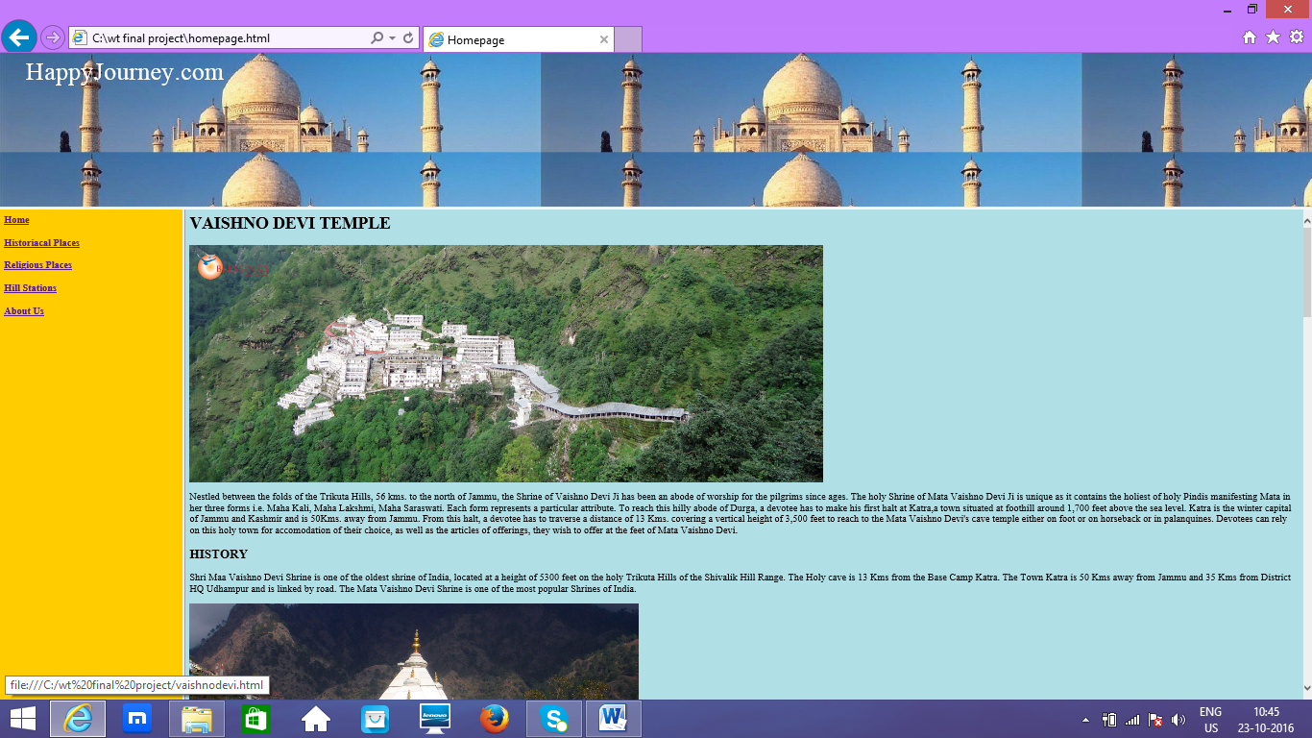

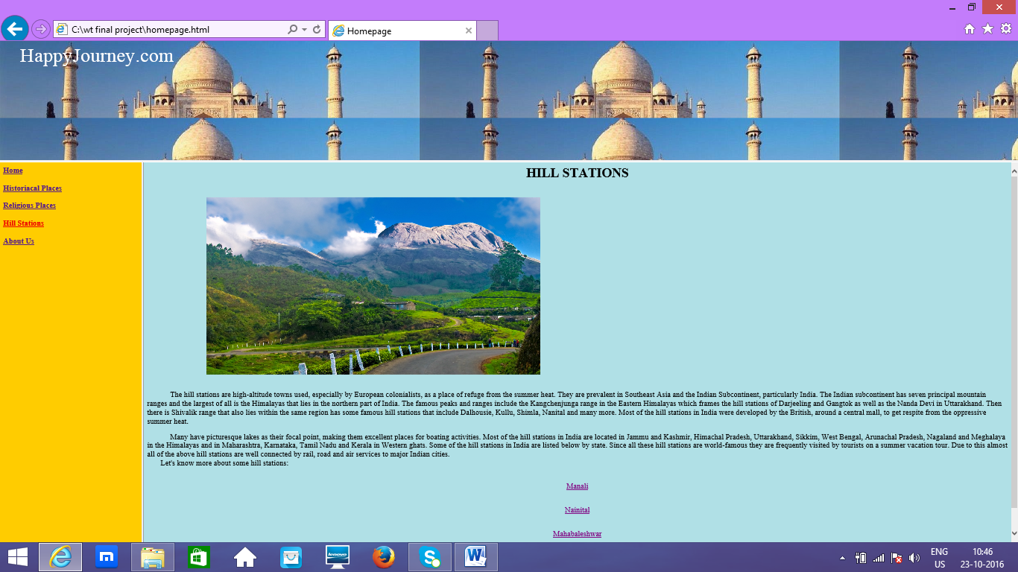

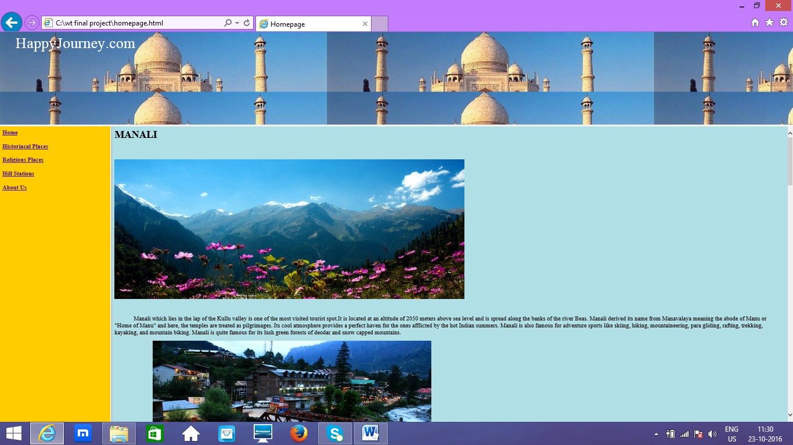

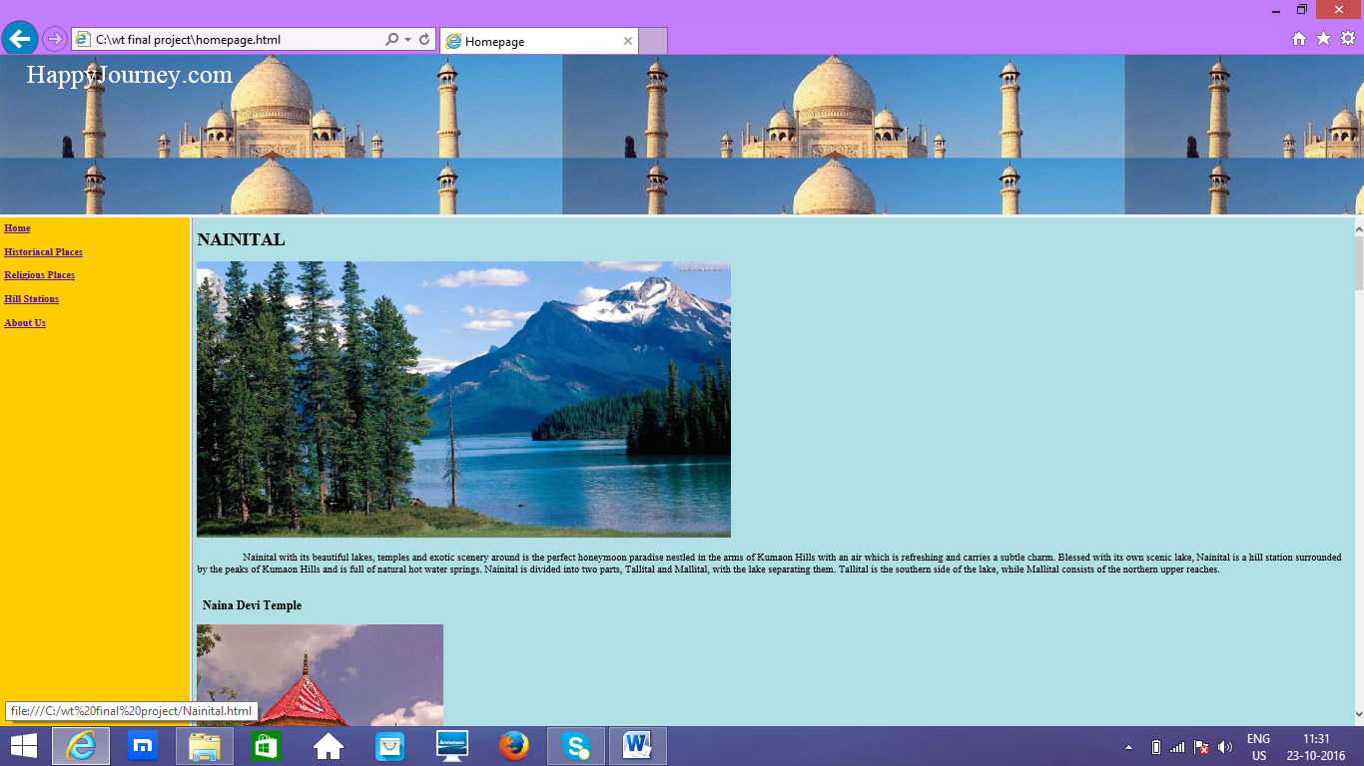

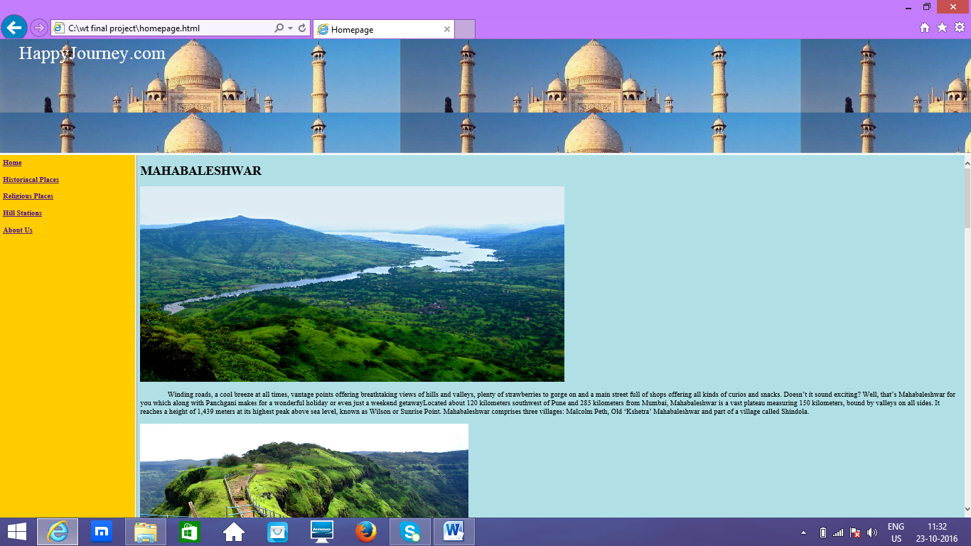

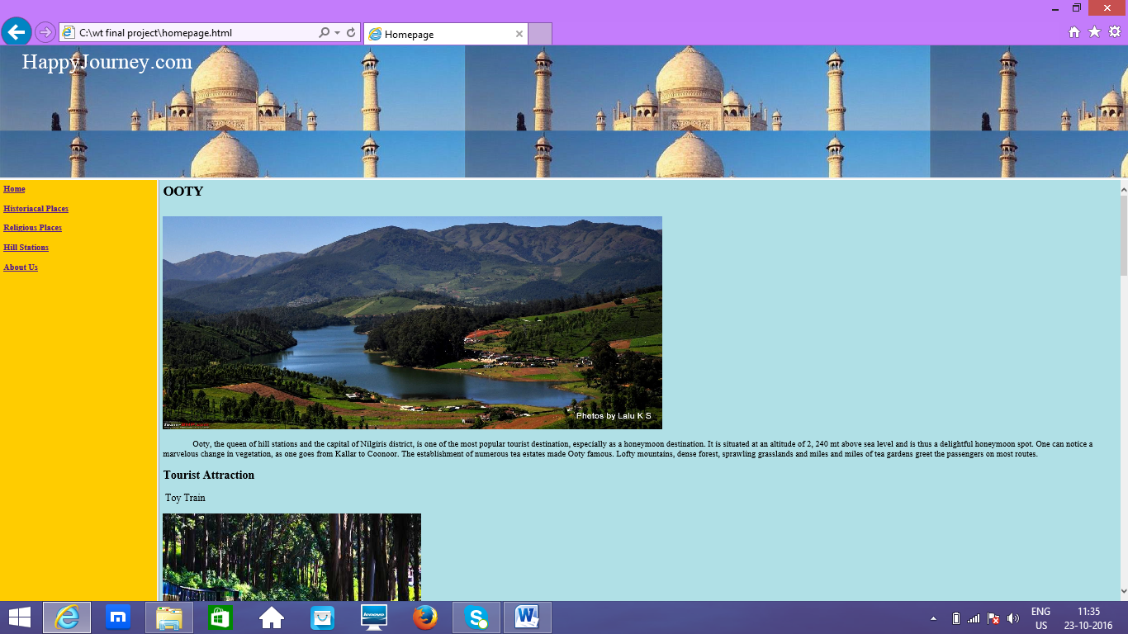

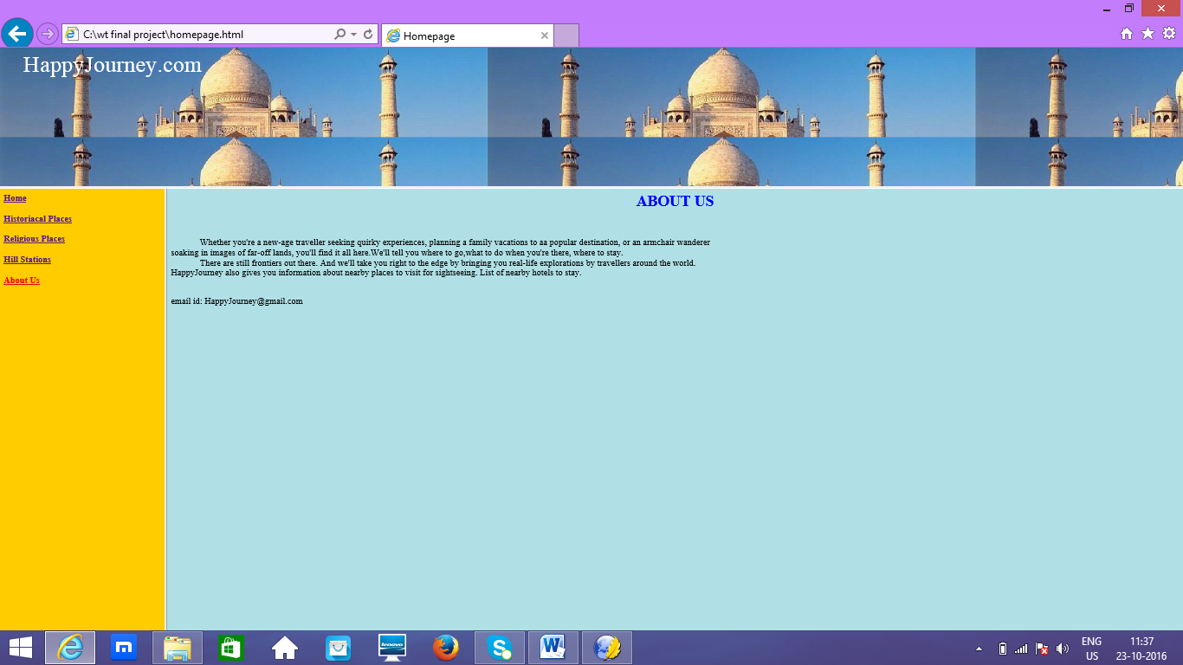

**References:**

[www.google.com](http://www.google.com)

[www.wikipedia.com](http://www.wikipedia.com)

[www.w3school.com](http://www.w3school.com)

[www.tutorialspoint.com](http://www.tutorialspoint.com)